Project Plan

List of Requirements

No | Priority | Requirement | Implications | Tasks
1 | MUST | To provide a friendly User Interface. | It would prevent the application from being accessible to the user. | Adequate research will be done to determine a GUI style which is very user-friendly and then a design will be produced by the Software Architect.
2 | MUST | Users can only access their space after the login. | User data at risk of not being secure. | User accounts will only be available to them if they can provide the correct authentication.
3 | MUST | Passwords will be saved securely locally. | Prevent unauthorised users from accessing sensitive data. | This will prevent other users from being able to access user password information which would then prevent them accessing other users accounts.
4 | MUST | A server or a broker will allow multiple authorised clients to connect to it. | If clients cannot connect to other clients through a server then clients will not be able to communicate with each other and if peer-to-peer networking was implemented, data would not be secure. | The application will not have peer-to-peer networking and the server will be active for as long as the application is required.
5 | MUST | The user will be able to create chat rooms (rooms: More than two contacts). | Users would not be able to communicate with their chosen clients. | Ensure that all exchanges have to occur through a chatroom even if it is only two people. (Which would be created anyway if one client decided to private message another).
6 | MUST | The user that creates a chat room will be promoted to admin of that chat room. | If there was no admin in place any user would have the ability to manipulate the chat room and their intentions may not be shared with other users. | Ensure that every chat room has an admin appointed with the ability for the admin to switch the position with another user if necessary.
7 | MUST | Moderators will be able to inherit all the admin permissions however moderators cannot demote the admin. | If moderators could demote the admin then a moderator would have all the functionality of an admin role which would cause the same issue found in risk(6). | Prevent the moderator role from being able to demote the admin and ensure the admin always as the most control regarding a specific chat room.
8 | MUST | Users will be able to see the active users in the chat room. | Users would not be able to see which other users are currently online and present in the chat room, preventing users waiting for responses when it may be easier to message the specific user privately. | If a user is present in a chat room, add an indication of that fact with either a green dot or the words online showing user status to all users in a specific chat room.
9 | MUST NOT | Clients will be able to connect directly to other clients without a server or a broker. | If clients could connect to other clients directly, then their data would not be secure and the application would not be used to handle sensitive data. | Ensure that only a client-server networking model is used for the application.
10 | SHOULD | Users will be logged off automatically after a specific amount of time of inactivity. | If users were constantly logged on then this could put a critical strain on the server potentially preventing the application from working as effectively. | Implementing a feature where after a specific amount of time the user will be removed from current chat rooms and signed out which not only limits server usage but will also benefit the user for security reasons.
11 | SHOULD | The client will list all the personal contacts in the contacts pane. | Not making a separate pane to hold contacts would risk accessibility of the application for the user as it may be difficult to find a specific client. | Creating a separate pane which holds the contacts that they have added and making it obvious how to use and access this pane would make navigating the application easier for the user..
12 | SHOULD | The user will be able to change their details including their picture. | Not allowing users to change their details and pictures risks other users from not being able to easily identify each other. | Implement a feature which allows a user to edit their account settings which will allow them to change their picture and personal information and then save that to the server.
13 | COULD | The full history of the conversation will be listed when a specific contact is selected. | Not having a full history transcript with appropriate contacts would risk the application not being effective as a work tool as previous work or conversations can not be viewed. | To ensure that the data is saved and protected, all conversation history will be saved server side and can only be accessed by logging into the application.
14 | COULD | The admin will be able to promote and demote users to moderators in channels. | The admin would not be able to change the chat room if it was necessary for example if a project leader switches roles with another member which would require them to inherit the moderator role. | Provide the functionality for the admin to view every member in the chat room and allow them to set or remove the appropriate roles as necessary.
15 | COULD | Offline messages will be stored in the client-side and transmitted to the target user(s) once they are online. | If the message is not stored client side then the transmission will be stored on the server until the destination client logs in which would waste server memory. | Before a message is sent, a check is performed to see if the destination client is online and if not then the transmission is postponed and only executed once the destination client is available to receive it.
16 | COULD | The application will allow exchanging files with contacts. | Not allowing the exchange of files would limit this application's potential as a workplace resource. | Ensuring that the ability to send and support a wide range of file types is available for all users.
17 | COULD | File transfer will only start if the contact clicks in the link. | Transferring files automatically could risk a bottleneck for the network as every user in one chat room will all be downloading the same files at the same time and some users may not need the download in the first place, thus wasting resources. | Adding to the exchanging file system by only allowing the download to commence once the user has selected the corresponding file link.
18 | COULD | The user will be able to send an emoji. | Not adding an emoji would make the platform inferior to similar applications because it's been standardised because of its usefulness to convey feelings quickly and efficiently. | This will be added as a branch to exchanging files where an emoji library will be incorporated into the messaging system.
19 | COULD | The users pictures will be displayed in the channels | Not having the pictures be displayed in a channel risks the other users not being able to quickly identify each other. | This will be implemented by exporting the file saved in each user's account settings and saving that to the server which is then displayed in chat rooms to other users once they are logged in the application.

Risk Analysis

No | Risk | Probability | Impact | Description | Action Plan
1 | Failure to resolve responsibilities (Operational risk) | 3 | 2 | Risks of loss due to improper process implementation failed system or some external events risks. | Multiple team meetings will be held across the development process in regards to assigning proper responsibilities for the work assigned for that time period, meetings will be extended or held another day to ensure all required responsibilities are assigned and that everyone understands what they are assigned.
2 | No Communication in the team (Operational risk) | 4 | 2 | Communication is vital within a group while completing the project. A lack of communication may lead to the failure of this project as regular meetings for project updates are of importance. | Due to the current pandemic and its restrictions on meeting face to face. The team has decided to communicate via conference call using Discord. Regular meetings for project updates will be held weekly.
3 | Wrong time estimation (Scheduling risks) | 3 | 5 | A lack of understanding of the undertaking of such a project and group work may lead to failures in correct time estimation for availability and work development. Leading to the missing of deadlines and a reduced work quality to compensate | Continued communication between each of the team members will be placed as a priority to ensure that our chosen schedule is held and deadlines are met.
4 | Resources are not tracked properly (Scheduling Risks) | 2 | 3 | With a decreased familiarity of our peers as a result of the pandemic we may not have an accurate estimation of our peers abilities and motivation. As a result delays and complications may arise in the development process | As stated before communication is a priority within the team so any complication should be picked up relatively quickly. Additionally cloud storage is being used for the material of our project, allowing for checks to be made to each other's current work completion and that standards are met.
5 | Failure to identify complex functionalities  (Operational Risk) | 3 | 5 | Due to limited familiarity of the concepts involved in creating such a program we may fail to properly identify critical/complex function. Leading to scheduling and operating issues. | Prior to the design stages of the program code team and individual research shall take place for the various functions of the program. The research done for each of the functions, either required or optional, shall be just as rigorous as any other of the functions, To allow for an accurate understanding of the workload ahead.
6 | Underestimating time required to develop complex functionalities (Scheduling Risk) | 3 | 4 | As a result of lower experience with handling such projects we may face difficulty in taking into account the various factors that may extend development time. | Continued communication between each of the team members will be placed as a priority to ensure that our chosen schedule is held and deadlines are met. Any deviances or complications that arise should be addressed As Soon As Possible by the team to allow for compensation or rescheduling to take place.
7 | Difficult project modules integration (Technical Risk) | 4 | 4 | As each of us will be taking on responsibilities for parts of the programs implementation, various coding habits miscommunication on the programs systems may complicate the final integration of modules through incompatible system functions. | Before the implementation process begins modules that will be dependent on one another will be assigned to the same programmer to ensure that the code within is  Utilising Githubs branching feature merging the various modules to one program should be simple enough by itself,
8 | Failure to address priority conflicts (Operational Risks) | 2 | 3 | During the implementation process various functions of the code will come into conflict due to various factors such incorrect coding, missing dependencies etc. Causing loss of functionality. | The situation will be assessed and prioritised depending on numerous factors. One being time estimation, work that requires the most time will be prioritised. Another one is perhaps urgency, work that needs to be completed before the deadline will also be prioritised.

 | January |  |  |  | February |  |  |  | March |  |  |  | April
 | W1 | W2 | W3 | W4 | W1 | W2 | W3 | W4 | W1 | W2 | W3 | W4 | W1 | W2 | W3 | W4
Requirement Meetings
Mind Map Completed
Design Database
Software Design
Interface Desi
M1 - Design Finished
Create Database
Develop Software
Prepare the reference manual
M2 - Development Finished
Perform System Testing
Document issues found and correct them
M3 - Testing Completed
System Maintenance
Evaluation
Final Report Submission
Project Design

Use Case Diagram:
Min Num = 3

Mobile User:

- Send/ Receive Messages
- Audio/Video Call
- Import/Export Media
- Access Settings
- Delete SMS
- Read/Reply

USER ---------- System --------- Admin

Admin:

- Add/ Remove Users
- Report Messages
- Create Group
- Add Description
- Update/Remove Profile Picture
- Speech Monitoring Management

Activity Diagram:
Min Num = 3

START

LOGIN (pass/fail)

SIGNUP (save username and password locally)

USER / ADMIN

INBOX / GROUP CHAT / CONTACTS

MESSAGE / CALL / LOG OFF

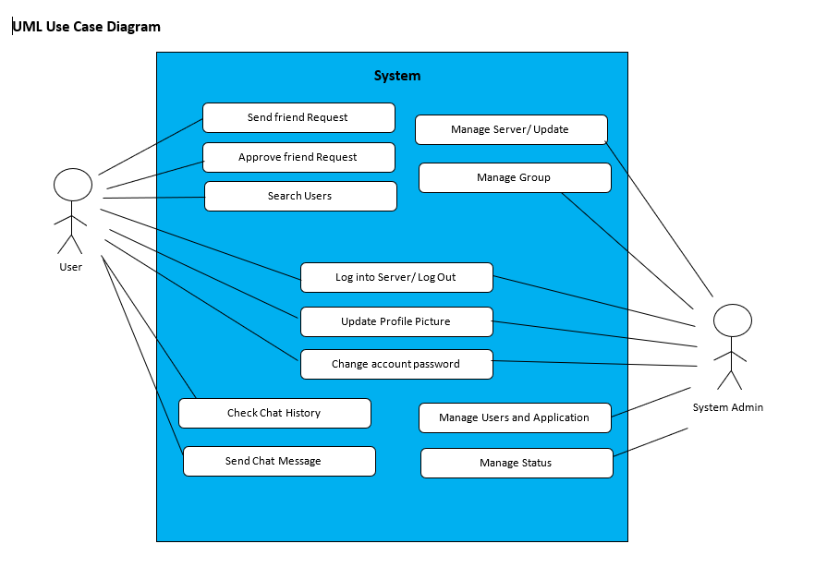

Class Diagram:
Min Classes Num = 5

USER account / ADMIN account / INTERFACE / MESSAGE RECORD / SERVER /
ADDRESS BOOK / STAFF

Sequence Diagram:
Min Num = 3

Client / ClientN / SERVER
send message
add people to group/ create group

(LOOP) if number = online send msg
else store locally msg and send when online
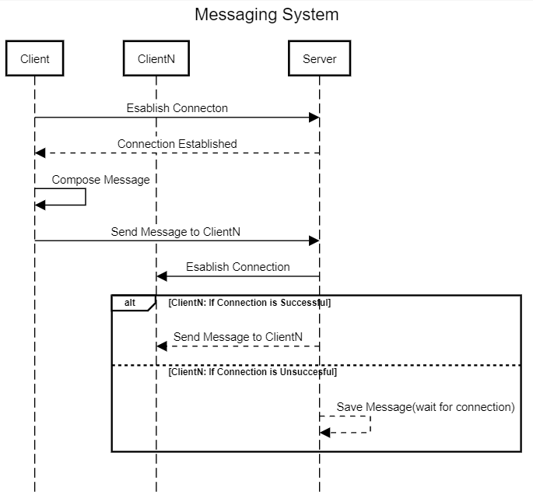

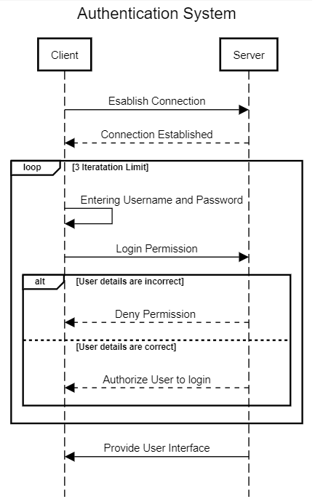

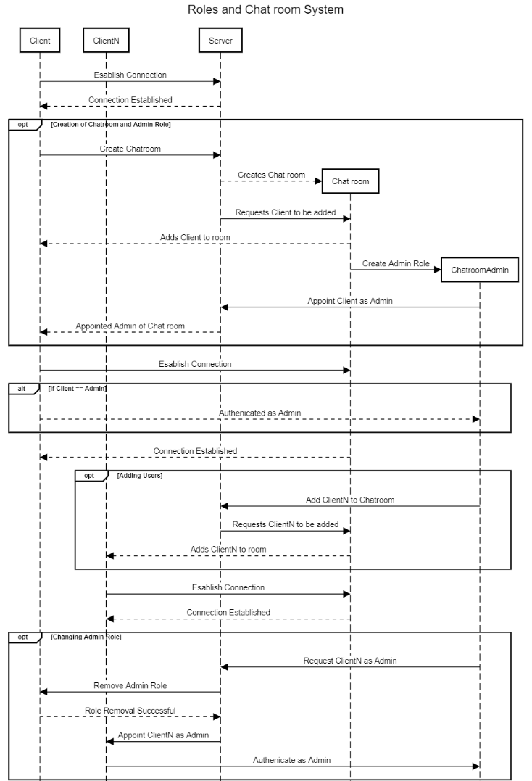

Component Diagram:
Min Num = 1

USER / ACCOUNT(customer details, payment) / server / recipient
ADMIN ---------------------------------------------------------//

FSM Diagram:
Min Num = 1

{Initial State} → Open App -> Type in username/password (loop back) -> type/send message -> Check If recipient is online (store locally) -> Uploading to Server -> (Recipient Online) -> Message Sent → {Final State Notation}

Communication Uml Diagram:
Min Num = 1

Use case: Sending a Message
USER account ------> Interface ------->Server------->ADDRESS BOOK / STAFF
//ADMIN account MESSAGE RECORD

Deployment Diagram:
Min Num = 1

User --> {Connection} → Modem ---> {Internet}

!GUI Mock-Up QT designer

